Stakeholder Analysis and Elicitation

- Stakeholder Matrix:

Sr.no | Stakeholder | Role | Influence | Interest | Engagement Strategy
1. | Karan Mehta | CEO | High | High | Manage closely – weekly briefings, decision authority, final sign-off
2. | Meera Iyer | Mobile App Dev Lead | High | High | Manage Closely – co create FRS, sprint reviews, primary technical partner
3. | Amit Joshi | Finance Manager | Medium | High | Keep On Side– refund logic sign-off, audit trail requirement review
4. | Rahul Desai | Senior CS Agent(SME) | Low | High | Keep informed – UAT participant, workflow validation, change champion
5. | Sunita Patil | Warehouse Lead | Low | High | Keep informed- warehouse dashboard UAT, notification flow validation
6. | Customer | End Users | Low | Medium | Monitor – survey post launch, track NPS and return resolution satisfaction

- Stakeholders Grid:

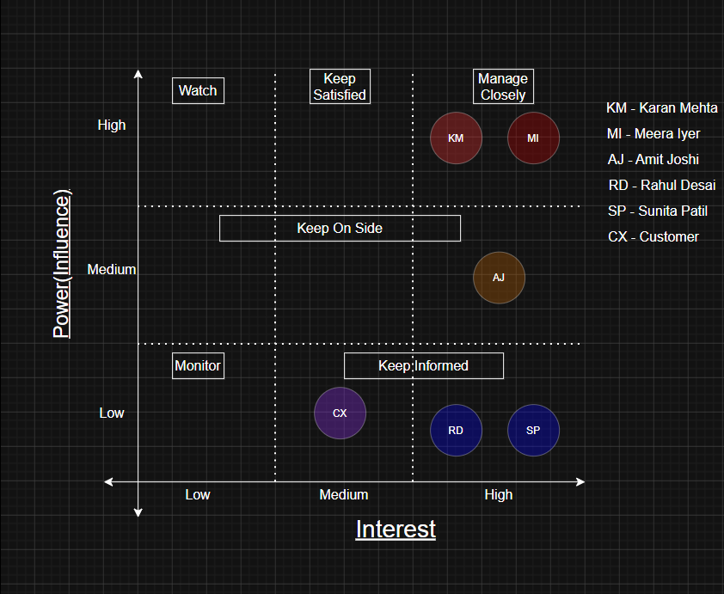

- RACI Matrix:

Activity | Karan  (CEO) | Pooja  (BA) | Meera  (Dev) | Rahul  (CS) | Sunita  (WH) | Amit  (Fin)
Define Business Objectives | A | R | I | C | I | C
Stakeholder Elicitation | I | R | I | C | C | C
BRD documentation | A | R | C | I | I | C
FRS Documentation | I | R | A | C | C | C
As-Is/To-Be Process Mapping | I | R | C | C | C | I
Product Backlog & Sprint Planning | I | R | A | I | I | I
System Development | I | C | R | I | I | I
UAT & Validation | A | R | R | C | C | C
Go-Live Approval | A | C | R | I | I | I
A
R
Responsible Accountable

Consultant Informed
C
I

- Pain Point Extraction

ID | Pain Point | Reported by | Impact | Severity
PP-01 | No structured return submission, customers send free-text emails with missing details | Rahul, All Agents | 2-3 email round trips per return, adds 1-2 days to resolution | Critical
PP-02 | Eligibility checked from an outdated, manually maintained Google Sheet | Rahul | Incorrect approvals – returns outside window are being accepted | Critical
PP-03 | Agents spend ~3.5 hrs/day on return emails because of which they don’t have time for other support tasks | Rahul, Karan | Agent burnout, SLA breaches other support tickets | Critical
PP-04 | Multiple agents can approve the same return – no duplicate prevention | Amit | 14 duplicate refunds last quarter = ₹ 38000 direct loss | Critical
PP-05 | Warehouse notified via WhatsApp with incomplete information – no advance panning | Sunita | Understaffed receiving bay, delays in item receipt confirmation | High
PP-06 | Refund triggered manually by Finance from unreliable shared spreadsheet | Amit | Batch processing delays refunds by 4-24 hrs.; missing entries cause non-payment | High
PP-07 | No audit trail – records spread across Gmail, WhatsApp, and multiple sheets | Amit | Cannot support financial audits or dispute resolution | High
PP-08 | Customers have zero visibility into return status for 8+days | Customers, Karan | Customer churn, brand damage, negative reviews | High
PP-09 | Return reasons captured accurately only 31% of the time (rest are free text) | Karan | No data on why return rate is 18% - cannot fix product issues | High
PP-10 | No return shipping label provided – customers arrange own courier at own cost | Customers | Friction in return process, no item tracking for warehouse | Medium

- Requirement Extraction – Pain Point->Business Requirement->Functional Requirement

PP | Pain Point | BR | Business Requirement | FR | Functional Requirement
PP-01 | Free-text emails with missing data | BR-01 | Customer initiates return online without contacting an agent | FR-01 | Structured return form with mandatory fields: item, reason dropdown, photo upload
PP-02 | Stale Google Sheet for eligibility check | BR-02 | System auto-checks eligibility using live order data | FR-02 | Eligibility validated in <=2 sec against OMS; 7-day window + ₹299 minimum enforced
PP-01,  PP-08 | No acknowledgement to customer on submission | BR-03 | Customer notified instantly on return submission | FR-03 | Automated confirmation email with Ref No. sent within 2 minutes of submission
PP-10 | No return label – customer arranges own courier | BR-04 | System auto-generates and delivers return shipping label on approval | FR-04 | PDF label with barcode emailed within 5 min of approval; barcode updates status to in transit
PP-08 | Zero customer visibility during 8+ day process | BR-05 | Customer can track return status in real time | FR-05 | Tracking page accessible via Ref No. showing all 7 stages with timestamps, updates in <=60 sec
PP-05 | WhatsApp notification with incomplete data | BR-06 | Warehouse auto-notified with full return details before item arrives | FR-06 | Structured warehouse dashboard notification within 1 min of approval; filterable by date and status
P-06 | Manual batch refund processing from unreliable sheet | BR-07 | Refund auto-triggered when warehouse confirms receipt | FR-07 | Confirm Receipt button triggers payment gateway API within 30 sec; status updates automatically
PP-09 | Return reasons only 31% captured accurately | BR-08 | Structures return reason captured on every submission | FR-08 | Mandatory reason dropdown (6 options) stored as queryable field; feeds analytics dashboard
PP-04 | Multiple agents approving same return | BR-09 | System detects and blocks duplicate return requests | FR-09 | Duplicate check on submission by Order ID + item; customer blocked, agent alerted
PP-09 | No management data on return trends | BR-10 | Management analytics dashboard showing return metrics | FR-10 | Dashboard: volumes, top 5 reasons, resolution time, refund totals; daily refresh; CSV/PDF export
PP-07 | No audit trail – records scattered and deletable | BR-12 | Complete immutable audit log for every return transaction | FR-12 | Every event timestamped with user ID; immutable; exportable as CSV for any date range

Interview Questions

INTERVIEW 1
Karan Mehta
Chief Executive Officer, RetailEasy Pvt. Ltd

Q. Can you describe the current returns situation from your perspective as CEO?
A. It’s a mess, honestly. We’ve grown 4x in orders over the last two years but our returns process is exactly the same as when we had 50 orders a day. It’s all emails and WhatsApp. My agents are drowning and customers are complaining. I saw a tweet last month from a customer saying our returns process is a joke. That’s the Kind of thing that kills brand reputation.
Q. What is the single biggest business problem this is causing?
A. Two things – money and data. Money because we had 14 duplicate refunds last quarter and Amit told me that was ₹38,000. But actually, the bigger issue is data. We have an 18% return rate and I have absolutely no idea why. Is it sizing? Product quality? Wrong description? I can’t fix what I can’t see.
Q. What does success look like to you once this portal is live?
A. Budget is approved but it’s not unlimited. We are not replacing Zoho CRM – that was an expensive implementation and it stays. Timeline – I want this live in 12 weeks. Meera said it’s doable if requirements are clear and stable. So that’s your job.
Q. Any concerns about the project?
A. Scope creep. Last time we did a tech project it started as a simple thing and ended up taking 8 months. I want a tight scope. Returns portal only. Not a full customer experience overhaul.
- Key Pain Points Identified
- No visibility into why products are being returned – 18% return rate with zero analytical insight
- Duplicate refunds causing direct financial loss (₹38,000 last quarter)
- Manual process has not scaled with 4x order volume growth
- Brand reputation at risk due to poor customer return experience
- CEO requirement : dashboard visibility by Monday morning post go-live

INTERVIEW 2
Rahul Desai
Senior Customer Service Agent, RetailEasy Pvt. Ltd.

Q. Walk me through your morning routine when you arrive at work.
A. I open Gmail and there are usually 60-80 emails waiting. At least 30 of them are return requests. I have to read each one, figure out what they want, reply asking for order ID and photos if they haven’t sent them, check the Google Sheet to verify the return window- the sheet is often outdated so sometimes I just guess – then forward to Sunita on WhatsApp. By the time I’ve done that it’s done that it’s 11:30 and I haven’t touched anything else.
Q. What is the most frustrating part of your current process?
A. Customers not including their order ID. I have to go back and forth two or three times just to identify who they are. Also, the Google Sheet. It’s shared with 3 other agents and half the time the delivery dates are wrong or missing. I once approved a return a return that was 14 days old because the sheet said it was delivered later than it actually was.
Q. Have there been cases where things went seriously wrong?
A. Yes. Twice this year I approved a return and another agent approved the same one. The customer got two refunds. Also, I sometimes forget to update the finance spreadsheet after approving. Then Amit comes to me a week later asking why a refund was processed without a record.
Q. What would make your job significantly easier?
A. If I didn’t have to touch returns at all for standard cases. If the system could automatically check eligibility, send the label, and notify Sunita – I should only be involved when something is unusual. Like a customer says the item was damaged but the system rejects it, then I can review manually. For normal returns I should just see a dashboard.
Q. How many returns would you say are straightforward vs. need agent intervention?
A. Honestly, About 80% are completely standard. Correct window, valid reason, photo attached. Those should just flow through automatically. The other 20% are edge cases- late returns, high value items, damaged goods disputes. Those I can handle.
- Key Pain Points Identified
- 3+ hours daily spent manually processing return emails – unscalable
- Google Sheet for order tracking is unreliable and frequently outdated
- Duplicated approvals by multiple agents causing double refunds
- Finance spreadsheet not updated consistently – audit gaps
- 80% of returns are standard and could be fully automated
- Agent should only be involved in exception/escalation cases

INTERVIEW 3
Sunita Patil
Warehouse Operations Lead, RetailEasy Pvt. Ltd.

Q. How do you currently find out that a return is coming to the warehouse?
A. Rahul sends me a WhatsApp message. Sometimes it's a forward of the customer's email. Sometimes it's just 'Sunita, return coming for order 4872, kurta, medium.' That's all the information I have. No timing, no courier details, nothing.
Q. What problems does that cause for warehouse operations?
A. I can't plan. On Tuesdays last week I had 11 returns arrive and I had only one person at the receiving bay because I didn't know they were coming. Items pile up, checking takes longer, and then the refund gets delayed because I haven't confirmed receipt yet. It's a ripple effect.
Q. What information do you need to process a return properly?
A. I need the order number, the item name and size, the reason for return, which courier is bringing it, and an expected date. If I have those five things I can prepare. Right now I get maybe two of them.
Q. How do you currently confirm that an item has been received?
A. I message Rahul on WhatsApp. He then tells Amit. Amit processes the refund. There is no system — it's just people messaging each other.
Q. What would the ideal system look like from your end?
A. Give me a simple screen where I can see all the returns that are approved and on their way. I want to see the item details, expected date, and a button to confirm receipt when it arrives. One click and the refund should happen automatically. I don't want to message anyone.
- Key Pain Points Identified
- No advance notice of incoming returns — cannot plan warehouse staff or space
- Incomplete information received (usually only order number, missing courier/date/item details)
- Return confirmation via WhatsApp chain — no system record, no audit trail
- Delayed receipt confirmation directly delays customer refund
- Warehouse needs: incoming returns list, item details, expected date, one-click receipt confirmation

INTERVIEW 4
Amit Joshi
Finance Manager, RetailEasy Pvt. Ltd.

Q. How does the refund process currently work from your side?
A. When a return is approved, Rahul is supposed to add a row to a shared Google Sheet with the order ID, amount, and customer details. I check that sheet every afternoon and process the refunds manually through the payment gateway portal. But the sheet is inconsistent. Sometimes entries are missing, sometimes they're duplicated.
Q. You mentioned duplicate refunds — can you tell me more about that?
A. Yes, it has happened at least twice this year that I know of. Two agents both approved the same return without knowing the other had done it. I processed both because both had entries in the sheet. We lost ₹38,000 in those 14 cases last quarter. Some of it we recovered by contacting customers, but not all.
Q. What is your biggest concern with the current process from a finance perspective?
A. Audit trail. If something goes wrong — a customer disputes a refund, or our auditors want to review Q3 transactions — I have no clean record. I have a Google Sheet that three people edit, WhatsApp messages, and email chains. That is not an audit trail.
Q. What would you need from the new system?
A. Automatic refund triggering — I should not be manually processing refunds one by one. And every transaction needs a timestamped record: who approved it, when the item was received, when the refund was triggered, what amount. I need to be able to export that for our auditors.
Q. Any concerns about automation of refunds?
A. One. For orders above ₹5,000 I want a manual review flag. The automatic process is fine for standard orders but for high-value ones I want to see it before it goes through.
- Key Pain Points Identified
- Manual refund processing from an unreliable shared Google Sheet
- Duplicate refund entries causing direct financial losses (₹38,000 last quarter)
- No clean audit trail — cannot support financial audits or dispute resolution
- High-value orders (above ₹5,000) require manual review flag before auto-refund
- Needs: automated refund trigger, timestamped transaction log, exportable audit report

